***MID TERM REPORT OF***

**Development of a GUI Based Control Scheme for Ball-on-Plate System**

*A Graduate Project Report submitted to Manipal Academy of Higher Education in partial fulfilment of the requirement for the award of the degree of*

**BACHELOR OF TECHNOLOGY**

**In**

**Electronics and Communication Engineering**

*Submitted by*

**K Akanksh Pratheek Reddy**

**Reg. No.: 140907050**

*Under the guidance of*

**Mr. Mukund Kumar Menon Dr. K Prabhakar Nayak**

**Asst. Professor, Senior Scale Professor**

**Dept of I&C Engg. Dept of E&C Engg.**

**DEPARTMENT OF ELECTRONICS AND COMMUNICATION ENGINEERING**

**MANIPAL INSTITUTE OF TECHNOLOGY**

(A Constituent Institution of Manipal Academy of Higher Education)

MANIPAL – 576104, KARNATAKA, INDIA

**MARCH/APRIL 2018**

**ABSTRACT**

Many Real world examples of systems to be controlled are non-linear, inherently unstable and can only be affected indirectly. With theoretical discussions of control at the undergraduate level focusing on linear systems, a gap exists between the basic theoretical simulations in academia and practice, but the gap can be bridged through an inherently unstable, multidimensional workbench system, on which various control algorithms can be implemented and hence visualized. Thus, the authors attempt to develop a linkage based Ball-on-Plate system, and an accompanying GUI based controller, with the capability to implement various control schemes.

The mechanical model was fabricated, with an aluminium frame under a smooth acrylic plate. The frame was connected to the base by the use of a Universal Joint. The actuation was developed in two iterations, with the initial 3 bar slider crank mechanism being rejected due to observed torsion, and a passive joint being added, making a 4 bar slider crank. A non linear mathematical model for the system dynamics was derived, based on the Lagrange-Euler equation and subsequently linearized based on fundamental assumptions stated in the report. A computer vision algorithm to extract the position coordinates of the ball with respect to the plate was developed and implemented based on surveyed literature.

The mechatronic system was extensively sweep tested. The computer vision algorithm was tested both for a single image and a video capture of the ball motion, and centroid of the ball was extracted in each frame. Alongside the derived mathematical model, the system and the sensing has been built.

The controller needs to be implemented, alongside a supporting GUI to aid ease-of-use and testability. The project makes use of the Raspberry Pi 3 B SBC system as an embedded device with processing done on MATLAB.

|  |  |  |  |  |  |
| --- | --- | --- | --- | --- | --- |
| **Contents** | | | | | |
|  | | | | | Page No |
| Abstract | | | |  | i |
|  | | | | | |
| **Chapter 1** | | | **INTRODUCTION** | |  |
|  | **1.1** | Introduction | | | 1 |
|  | **1.2** | Background and Motivation | | | 1 |
|  | **1.3** | Literature Review | | | 2 |
|  | **1.4** | Objectives | | | 3 |
|  | **1.5** | Summary | | | 3 |
|  | | | | | |
| **Chapter 2** | | | BACKGROUND THEORY | |  |
|  | **2.1** | Introduction | | | 4 |
|  | **2.2** | Basics of Nonprehensile Robotics | | | 4 |
|  | **2.3** | Mathematical Model: Introduction | | | 5 |
|  | **2.4** | Computer Vision | | | 5 |
|  | **2.5** | Summary | | | 6 |
|  | | | | | |
| **Chapter 3** | | | **METHODOLOGY** | |  |
|  | **3.1** | Introduction | | | 7 |
|  | **3.2** | Proposed Solution | | | 7 |
|  | **3.3** | Implementation | | | 8 |
|  | **3.4** | Summary | | | 13 |
|  | | | | | |
| **Chapter 4** | | | **RESULT ANALYSIS** | |  |
|  | **4.1** | Introduction | | | 14 |
|  | **4.2** | Results | | | 14 |
|  | | | | | |
| **Chapter 5** | | | **CONCLUSION AND FUTURE SCOPE** | |  |
|  | **5.1** | Work Conclusion | | | 19 |
|  | **5.2** | Future Work | | | 19 |
|  | | | | | |
| **REFERENCES** | | | | | **20** |
| **PROJECT DETAILS** | | | | | **21** |

**CHAPTER 1**

**INTRODUCTION**

**1.1 Introduction**

This chapter introduces nonprehensile manipulators, of which Ball-on-Plate systems are an example. The relevance of the system in practical terms is drawn from the author’s previous work. Through an extensive literature review, the objectives for the project are stated.

**1.2 Background and Motivation**

Nonprehensile robots are vastly underexplored; consisting of manipulating an objects position/orientation without grasping it. Normally, nonprehensile modes of object manipulation include pushing, impact, rolling, flipping etc. Nonprehensile manipulation takes advantage of the geometry of the manipulator as well as that of the object being manipulated in order to achieve a larger workspace, faster and minimalistic. Nonprehensile based object handling is very effective for objects that are too heavy/large/fragile, which conventional mechanical grippers fail to achieve. However, mechanisms involving nonprehensile modes are generally highly complex because the governing equations of motions are nonholonomic. Since robots designed for nonprehensile modes of object handling are based upon the geometry of the object, any change in the object structure can severely affect the structure of the state model of the system. Hence, this class of manipulators provides a formidable control problem.

In a previous work, the author built an obstacle clearing hexapod. However, the control schemes required for obstacle clearance were unable to be tested before implementation, due to a lack of a necessarily complex test system, and had to be directly tried on the system. This led to a search for a suitable test bench, leading to the Ball-on-Plate system.  
  
Through introductory courses to Linear Control Theory, the focus is on simple and linear systems. Many real world and industrial examples of systems to be controlled are non-linear, inherently unstable and can only be affected indirectly. Thus, the author noticed a gap between the basic theoretical simulations in academia and practice, and felt the best way to bridge the gap is through an inherently unstable, multidimensional workbench system, on which various control algorithms can be implemented. The BnP system will provide users with a platform to test and compare various aspects of control systems without getting caught up in the lower level hardware development. This will also add an intermediate step in the control design for high level systems, particularly in the field of biomechanics and Human-Robot Interaction, verifying the efficiency of the algorithm in practical conditions.  
  
**1.3 Literature Review**

While the ball and beam platform (a problem centered on balancing a ball along a rigid beam) has seen substantial research interest, the more complex 4 DOF ball-on-plate platform has not attracted as much attention. Nevertheless, a significant amount of research has focused on the ball-on-plate problem. Awtar, Bernard et al. [1] have built a ball-on-plate system using a novel spatial linkage mechanism for actuation and a resistive touchscreen for sensing. The plate is connected to the base via a Universal joint. The authors have explained the merits and demerits of various ball sensing systems, which serves as a useful guide for sensing system selection.  
  
Another paper of interest is by Knuplez, Chowdhury et al. [2] who have developed a ball-on-plate system using a discrete lead compensator as the controller. The authors have used Euler-Lagranges equations to mathematically describe the dynamics of the system, and provided important assumptions to take into consideration for mathematical modelling of the system. A relevant work (Park, Lee) [3] addresses the problem using a machine vision system for sensing. The authors have used a 6 DOF industrial robot for manipulation of the plate. The machine vision algorithm here, especially the method used to estimate the center of the ball is of interest and has proven useful as a jumping off point from which to develop our sensing system. Moarref, Saadat, and Vossoughi [4] have also provided a heuristic technique for sensing ball position using MATLAB. This technique is simpler than the technique used by Park and Lee, however, the performance difference has not been explored or specified in the paper. The authors have used a PID controller, with a fuzzy controller which supervises the gains of the PID controller. The fuzzy rules have been derived experimentally. Jadlovska and Jajcisin [5] have implemented position control on a Ball-on-Plate system using a PID control scheme, and have verified the same through a simulation in SIMULINK.  
  
Nokhbeh and Khashabi [6] have performed a simulation of a Ball-on-Plate system, while deriving the non-linear differential equations of the system. While this paper serves as a useful guide to mathematically modeling Ball-on-Plate systems the results are based on simulations of the system, and hence real-life performance has not been explored.

Many publications implementing BnP systems have focused on BnP systems purely from the point of view of a challenging design problem, or as a benchmark for testing control systems [4] [7] [2]. However, although a few of these publications have suggested the use of BnP systems as educational tools [5], the overall implementation of BnP systems for this purpose has been limited.

**1.4 Objectives**

* Development of a linkage based Ball-on-plate (BnP) system
* Design and implementation of a GUI based controller for the proposed BnP  
  model

**1.5 Summary**

This chapter acts as a brief introduction to nonprehensile manipulators, as well as  
a literature review covering relevant works for the ball-on-plate system. Finally,  
based on the review, the objectives have been stated.

**CHAPTER 2**

**BACKGROUND THEORY**

**2.1 Introduction**

This chapter introduces nonprehensile robotics, along with its advantages and disadvantages. The chapter also discusses the mathematical modelling of the system, and analyses the need for a computer vision system.

**2.2 Basics of Nonprehensile Robotics**

Nonprehensile manipulation, in the context of robotics, is the use of low-degree-of-freedom robots to perform complex tasks by manipulation without a form or force closure grasp. By not grasping, the robot can use gravitational, centrifugal, and Coriolis forces as virtual motors to control more degrees of freedom of a part. The part’s extra motion freedoms are exhibited as rolling, slipping, and free flight, etc.

Nonprehensile manipulation offers several potential benefits:

* New Robot Primitives: Nonprehensile manipulation provides an option for a robot when it must manipulate an object too large or too heavy to be grasped and lifted.
* Simpler manipulators: The structure of the manipulator can be simplified by eliminating the gripper
* Flexibility: Grippers are often designed to grasp parts of particular shapes and sizes. With nonprehensile manipulation, if the robot can apply a force to the part, it can manipulate the part. Nonprehensile manipulation allows a manipulator to control multiple parts simultaneously, using whatever surfaces of the manipulator are available.
* Increased workspace dimensionality: When an object is carried with a grasp, the manipulator must have at least as many degrees of freedom as has the object we want to control. If we allow the object to move relative to the manipulator, we can control more degrees of freedom than the manipulator itself has. This is referred to as underactuated manipulation.

These advantages come at the cost of increased complexity in planning and control. The planning for a prehensile pick-and-place manipulator only needs a kinematic model of the world. However, a system like the ball-on-plate requires a dynamic model, describing the relation between the forces and their resulting motion. It can be said that the complexity is being transferred from hardware to planning and control.

**2.3 Mathematical Model: Introduction**

The goal of the mathematical model is to derive a relationship between the actuation parameters (controllable parameter), and the ball position (controlled parameter). It is important to note that the mathematical relationship between the plate angle and ball position is independent of actuation mechanism used. Only the relationship between the actuation parameter and the plate angle is specific to the actuation mechanism. For example, Ker, Ling, and Wong’s Ball-on-Plate [8], based on magnetic levitation, uses current through magnetizing solenoids as the actuation parameter. The derivation of the mathematical model for the authors Ball-on-Plate model has been done in Chapter 3, where it can be seen that the actuation parameter is the motor angle.

Before the model is derived, the following simplifications will be assumed [1]:

* The ball does not experience slippage on the plate
* The ball is homogeneous and symmetric
* The system is frictionless
* The ball does not lose contact with the plate at any given time, i.e., it does not bounce or slip off the plate

The author chose to go with the Lagrangian system of mechanics because unlike Newtonian system of mechanics, one can use a set of generalized coordinates consistent with the constraint relations. The number of those generalized coordinates are the same with the number of degrees of freedom of the system. This simplifies the derivation of the model.

**2.4 Computer Vision**

Many Tasks routinely performed by humans (for example machine control, driving, assembly, or fruit picking) are based on visually perceived information. In order for robots to perform such tasks, without extensive Instrumentation or re-engineering of the environment, they must also have The ability to perceive and act upon visual information. Computer vision is Therefore an important sensor for robotic systems since it mimics the human Sense of vision and allows for non-contact measurement of the environment.

Typically, CV systems for robotic manipulation adopt a ’look’ then ’move’ strategy – a well calibrated camera and vision system determines the desired robot end-effector pose and the robot system is commanded to make the appropriate motion.[9] The accuracy of the resulting motion clearly depends directly on the quality of the Camera calibration and the accuracy of the robot. A good level of precision can be achieved using high quality components and good systems engineering.

An alternative approach to increasing the performance of the overall system is to use a vision system to continuously guide, or steer, the robot end effector toward the target. Such a closed-loop Position control structure is referred to as a visual servoing system. A visual-feedback control loop, like any feedback control system, will increase closed-loop accuracy and robustness to error in the sensor or the robot – allowing the accuracy of vision system to be relaxed while maintaining overall accuracy.

**2.5 Summary**

This chapter covered essential background theory for the Ball-on-Plate system, including the sensing system (Computer Vision), mathematical modelling, and basics of nonprehensile robotics.

**CHAPTER 3**

**METHODOLOGY**

**3.1 Introduction**

This section will discuss the proposed solution, along with constraints to take into consideration while constructing the system. Further discussion focuses on mathematically modelling the system, as well as development of the computer vision system for sensing ball position and hardware design of the system.

**3.2 Proposed Solution**



Figure 3.1: Ball-on-Plate system block diagram

The image of the plate surface captured by the camera is processed by the CV algorithm, and the position of the ball, with respect to the plate edges is extracted. These coordinates are compared to the goal position, and the controller runs with the goal of minimizing this error. The output of the controller is in the form of servo angles, which are used to change the position of the plate on the mechatronic system, which in turn affects the position of the ball, leading into the next iteration of the loop.

Some of the constraints to take into consideration while constructing the Ball-on-Plate system are as follows:

* Weight of the plate: Directly affects the number of actuators and Torque required at each of them.
* Structural characteristics of the plate: The flexibility, smoothness and possibility of lag at center need to be considered while choosing the plate material in addition to the weight. The choice of adding a supporting frame structure was also made.
* Choice of Servo Motor: Radial distance between motor and plate affects the torque required. Resolution and Deadband are further considerations.
* Sensing: The specifications of the camera in terms of available frame rate and resolution need to be considered. A camera stand needed to be fabricated with adjustable height such that the principal axis of the camera coincides with the center of the plate.
* Power supply: Components such as SMPS and buck regulators were selected so as to deal with the worst case scenario of all motors drawing stall current.

**3.3 Implementation**

*3.3.1 Hardware Implementation*

This section will deal with the construction of the system. The plate is a square white acrylic sheet of side 1 ft (30.46 cm). It has been reinforced with a frame of aluminium, to eliminate any possible bending of the plate. The plate is attached to the frame via thin rubber strips, using a cyanoacrylate based adhesive. At the center of the plate, a vanadium steel universal joint of 1 inch (0.635 cm) drive is attached. The universal joint, as well as the plate itself are detachable from the frame, thus ensuring that in the case of any damage to the plate or the U-joint, they can be replaced. The universal joint slots into an extender bar which is attached to the particle board base. For the ball-on-plate system, the author has chosen a 4 bar slider crank mechanism for the linkages. Each linkage is attached to the frame via a revolute joint. The revolute joint is attached to the aluminium frame using a cyanoacrylate based adhesive. This mechanism went through two iterations before being finalized. The author initially went with a 3 bar linkage system. However, upon testing the motion of the system via single axis motor sweep tests (rotating pair of motors to achieve plate angle change in one axis), along with the change in plate angle, plate torsion (up to 20 degrees) was observed, therefore leading to a dependence of change in plate angle in one axis upon the other axis. This was deemed unacceptable. Further testing through motor sweeps revealed the cause of this torsion – the servo-motor fans were vibrating with respect to the crankshaft. This was solved by adding a passive joint to the crankshaft, thus converting the 3 bar linkage into a 4 bar linkage.

In comparison with previous implementations of linkage based ball-on-plate systems with 2 motors for actuation (one for each axis), the author has chosen a 4 motor design, with two diametrically opposite motors per axis attached via linkages to the frame. Each motor pair rotates as a complement, i.e., when one motor rotates a certain angle clockwise, thus pushing the plate upwards, the other motor simultaneously rotates the same angle anticlockwise, pulling the plate downwards. A 4 motor design is advantageous in the sense that it offers greater mechanical stability and ensures that the requisite load is halved for each motor.

Considering accuracy is an essential quality of the system, servo motor selection is an important part of the hardware design. In comparison with analog servo motors commonly found in the market (such as TowerPro MG 995), digital servos are advantageous. The feedback signals of digital servos are analyzed by a microprocessor which then sends high frequency voltage pulses to the motor. This gives the advantages of improved deadband, resolution, and superior centering. Due to the aforementioned advantages, RKI-1211 digital servo motors were selected [10].

Another important aspect of the hardware design is the selection of components for the power supply to the motors. The maximum current taken by each servo, referred to as stall current, is 1.5 A. Hence, assuming a worst case scenario of simultaneous stalling of all four servos, the maximum possible current taken by the system is 6A. A DC SMPS is used, which supplies up to 10A at 12V. As the motors are rated at 6V, two adjustable DC-DC buck converters connected to the SMPS (each rated at 3A) are used for each pair of motors. A camera stand has been constructed. The stand consists of two aluminium bars attached to the particle board base at opposite corners. The stand is constructed in such a way as to make the height adjustable. A Raspberry Pi 3 B single board computer has been used for motor control.

*3.3.2 Mathematical Model: Derivation*

Here, the author will derive the mathematical model for the system using Lagrangian and taking the assumptions discussed earlier in Chapter 2.

The Euler-Lagrange Ball-Plate system equation is as following:



Where qi stands for i-direction coordinate, T is kinetic energy of the system, V is potential energy of system and Qi is composite force. The system has 4 degrees of freedom; two in ball motion and two in inclination of plate. Here we assume the generalized coordinates of system to be xb and yb for ball’s position on plate and α and β for the inclination of the plate.

The kinetic energy of ball consists of both rotational with respect to its center of mass and translational kinetic energy:



Where mb is the mass of the ball, Ib is moment of inertia of the ball; b and b are ball’s translational velocities along x-axis and y-axis; x and y are ball’s rotational velocities along x-axis and y-axis.

The following relations between translational velocities and rotational velocities can be used to simplify the above equation:



In which rb denotes ball’s radius. By substituting the above relation into equation 3.2, the following relation is obtained:



The kinetic energy of the plate, by considering ball as a point mass which is placed in (xb; yb), consists of its rotational energy with respect to its center of mass:



Where α and β are plate’s angle of inclination along x-axis and y-axis, respectively. Therefore $\dot{α}$ and $\dot{β}$ are plate’s rotational velocity.

Hence the Kinetic Energy of the system can be calculated as following:



The potential energy of the ball relative to horizontal plane in the center of the inclined plate can be calculated as:



Here we can derive the system’s equation by Lagrangian and equations 3.3-3.7:



We use L to derive system’s equations:









We assume generalized torques as τx and τy which are exerted torques on the plate. From Lagrange-Euler equation we can write:

 (3.13)

 (3.14)

 (3.15)

 (3.16)

Substituting the relations derived in 3.9-3.12 in 3.13-3.16, the following non-linear equations of the system are obtained:

 (3.17)

 (3.18)

 (3.19)

 (3.20)

The equations (3.17) and (3.18) give the relation between ball state and plate state. The equations (3.19) and (3.20) show the effect of external torque on the ball-on-plate system.

These equations are non-linear. In order to apply controllers consistent with linear control theory, the system is linearized about its operating point. To linearize the system, we take the following simplifications:

* Small angle of inclination for the plate $α \text{≪}\text{ 1 and }β \text{≪ 1 → sin} ≈ α, \sin{β ≈ β}$
* Slow rate of change for the plate $\dot{α}\text{ ≈ 0 and }\dot{β}\text{ ≈ 0 → }\dot{α} \dot{β }\text{ ≈ 0 , }{ \dot{α}}^{2}\text{ ≈ 0, }{ \dot{β}}^{2}\text{ ≈ 0 }$
* Solid ball with moment of inertia = $\frac{2}{5}m_{b}r_{b}^{2}$

 (3.21)

 (3.22)

As discussed previously, the author’s implementation is a slider-crank linkage based system. Here, the relationship between plate angle and motor angle is given as follows:

 (3.23)

Where αc is the crankshaft angle, αp is the plate angle of inclination, lp is effective length of plate, lc is length of crankshaft. Angles are in radians.

In the author’s implementation, maximum crankshaft angle is π radians, effective length of plate is 15.24 cm, and crankshaft length is 2.54 cm. Therefore, the maximum plate angle is $\frac{π}{6}$ radians, or 30◦.

3.3.3 Software Implementation

The computer vision algorithm was inspired by the work of Moarref. [4]. The region of interest of the camera frame, consisting of the plate and the ball placed on it, are binarized such that the ball is foregrounded with white pixels and the plate is in the background as ball. From the assumption of symmetry, it can be implied that the center of the ball is surrounded by the most number of white pixels on each side. Therefore, on the summation of pixel values across each row (column) and finding the maxima, the y - coordinate (x - coordinate) of the centroid can be acquired. For faster calculations in real time, the summation is only done in the vicinity of the previously calculated centroid.

The actuation of the servo is done directly from MATLAB, linking to the Raspberry Pi 3 B SBC. The default GPIO control libraries on the Raspberry Pi (the rpi.GPIO module suffers from a disadvantage that renders it unsuitable for servo motor control - it is incapable of applying hardware PWM, thus causing severe jitter. However, the custom pigpio C library [11] offers hardware PWM. MATLAB provides a wrapper around pigpio module, obtaining C like speeds in the control.

**3.4 Summary**

In this chapter, a discussion on the hardware as well as software design was conducted, as well as a mathematical model using Lagrangian system of equations was derived.**CHAPTER 4**

**RESULT ANALYSIS**

**4.1 Introduction**

This chapter will discuss current results obtained through hardware and software testing including tests performed on the computer vision system, as well as the mechanical design.

**4.2 Results**

Both iterations of the mechanical model were extensively tested. The plate was first sweeped through each axis independently and then simultaneously, going through the full range of motion of the system. The speed of motion was varied as well, to test stability, and the system performed satisfactorily on all counts.

For initial testing of the Computer Vision system, images of a ball placed on the plate were taken by an external camera and the algorithm was run, with satisfactory results. This was extended to a video with 25 frames, and the centroid of the ball in each frame was calculated, thus extracting the trajectory of the ball.

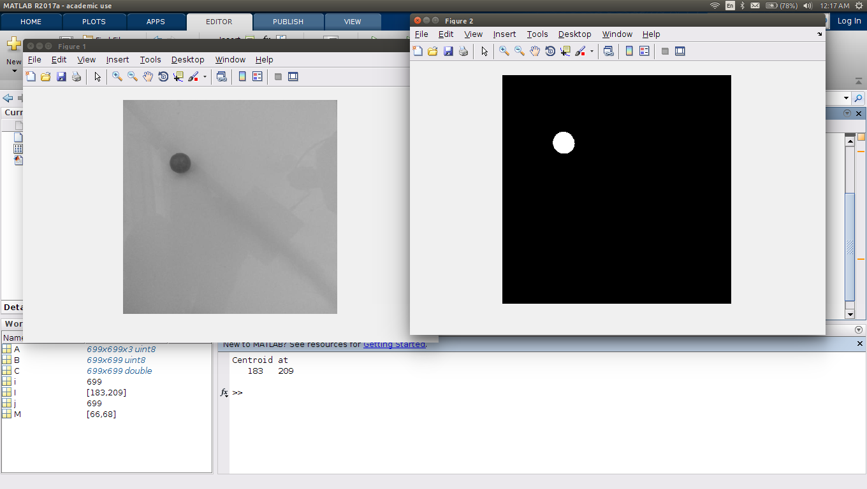

Figure 4.1: Initial Testing of CV algorithm to locate Centroid

This was extended to a video with 25 frames, and the centroid of the ball in each frame was calculated, thus extracting the trajectory of the ball. Testing was performed as follows:

* Plate is tilted by hand
* Overhead camera is switched on
* While overhead camera is recording video, a solid rubber ball of 1 inch diameter is placed at a vertex and made to roll, sliding on the plate. The motion is captured in 25 frames, and it is stored in '.avi' format, timed at 1 second.
* Trial is repeated for different angles of plate

10 trials were obtained, and video was processed for the ball centroid using the CV algorithm. A timer was run through software to evaluate processing time.

Table 4.1: Computer Vision System Testing

|  |  |
| --- | --- |
| Trial No. | Processing Time per 25 frames |
| 1 | 0.36 seconds |
| 2 | 0.40 seconds |
| 3 | 0.42 seconds |
| 4 | 0.32 seconds |
| 5 | 0.40 seconds |
| 6 | 0.36 seconds |
| 7 | 0.36 seconds |
| 8 | 0.38 seconds |
| 9 | 0.32 seconds |
| 10 | 0.34 seconds |

From above table, average processing time per 25 frames = 0.36 seconds. Below in figure 4.2, a trajectory of one of the trials is displayed, with calculated centroid in the form of white dots per frame.



Figure 4.2: Sample ball trajectory for one trial

As discussed previously, the mechanical design went through 2 iterations. It can be seen from figure 4.3 that the linkage is attached to the frame via a revolute joint.



Figure 4.3: Revolute joint

The particle board base is shown in figure 4.4 - the complementary motor design can be clearly seen here.



Figure 4.4: Base

In figure 4.5, the initial 3 bar linkage is shown - this was later replaced with a

4 bar linkage due to torsion.



Figure 4.5: First iteration: Linkages

In figure 4.6, the adjustable height camera superstructure is shown. Note the

placement of the Raspberry Pi SBC atop the structure.



Figure 4.6: Camera superstructure

Figure 4.7, the final torsion-free 4-bar slider crank linkage is displayed.

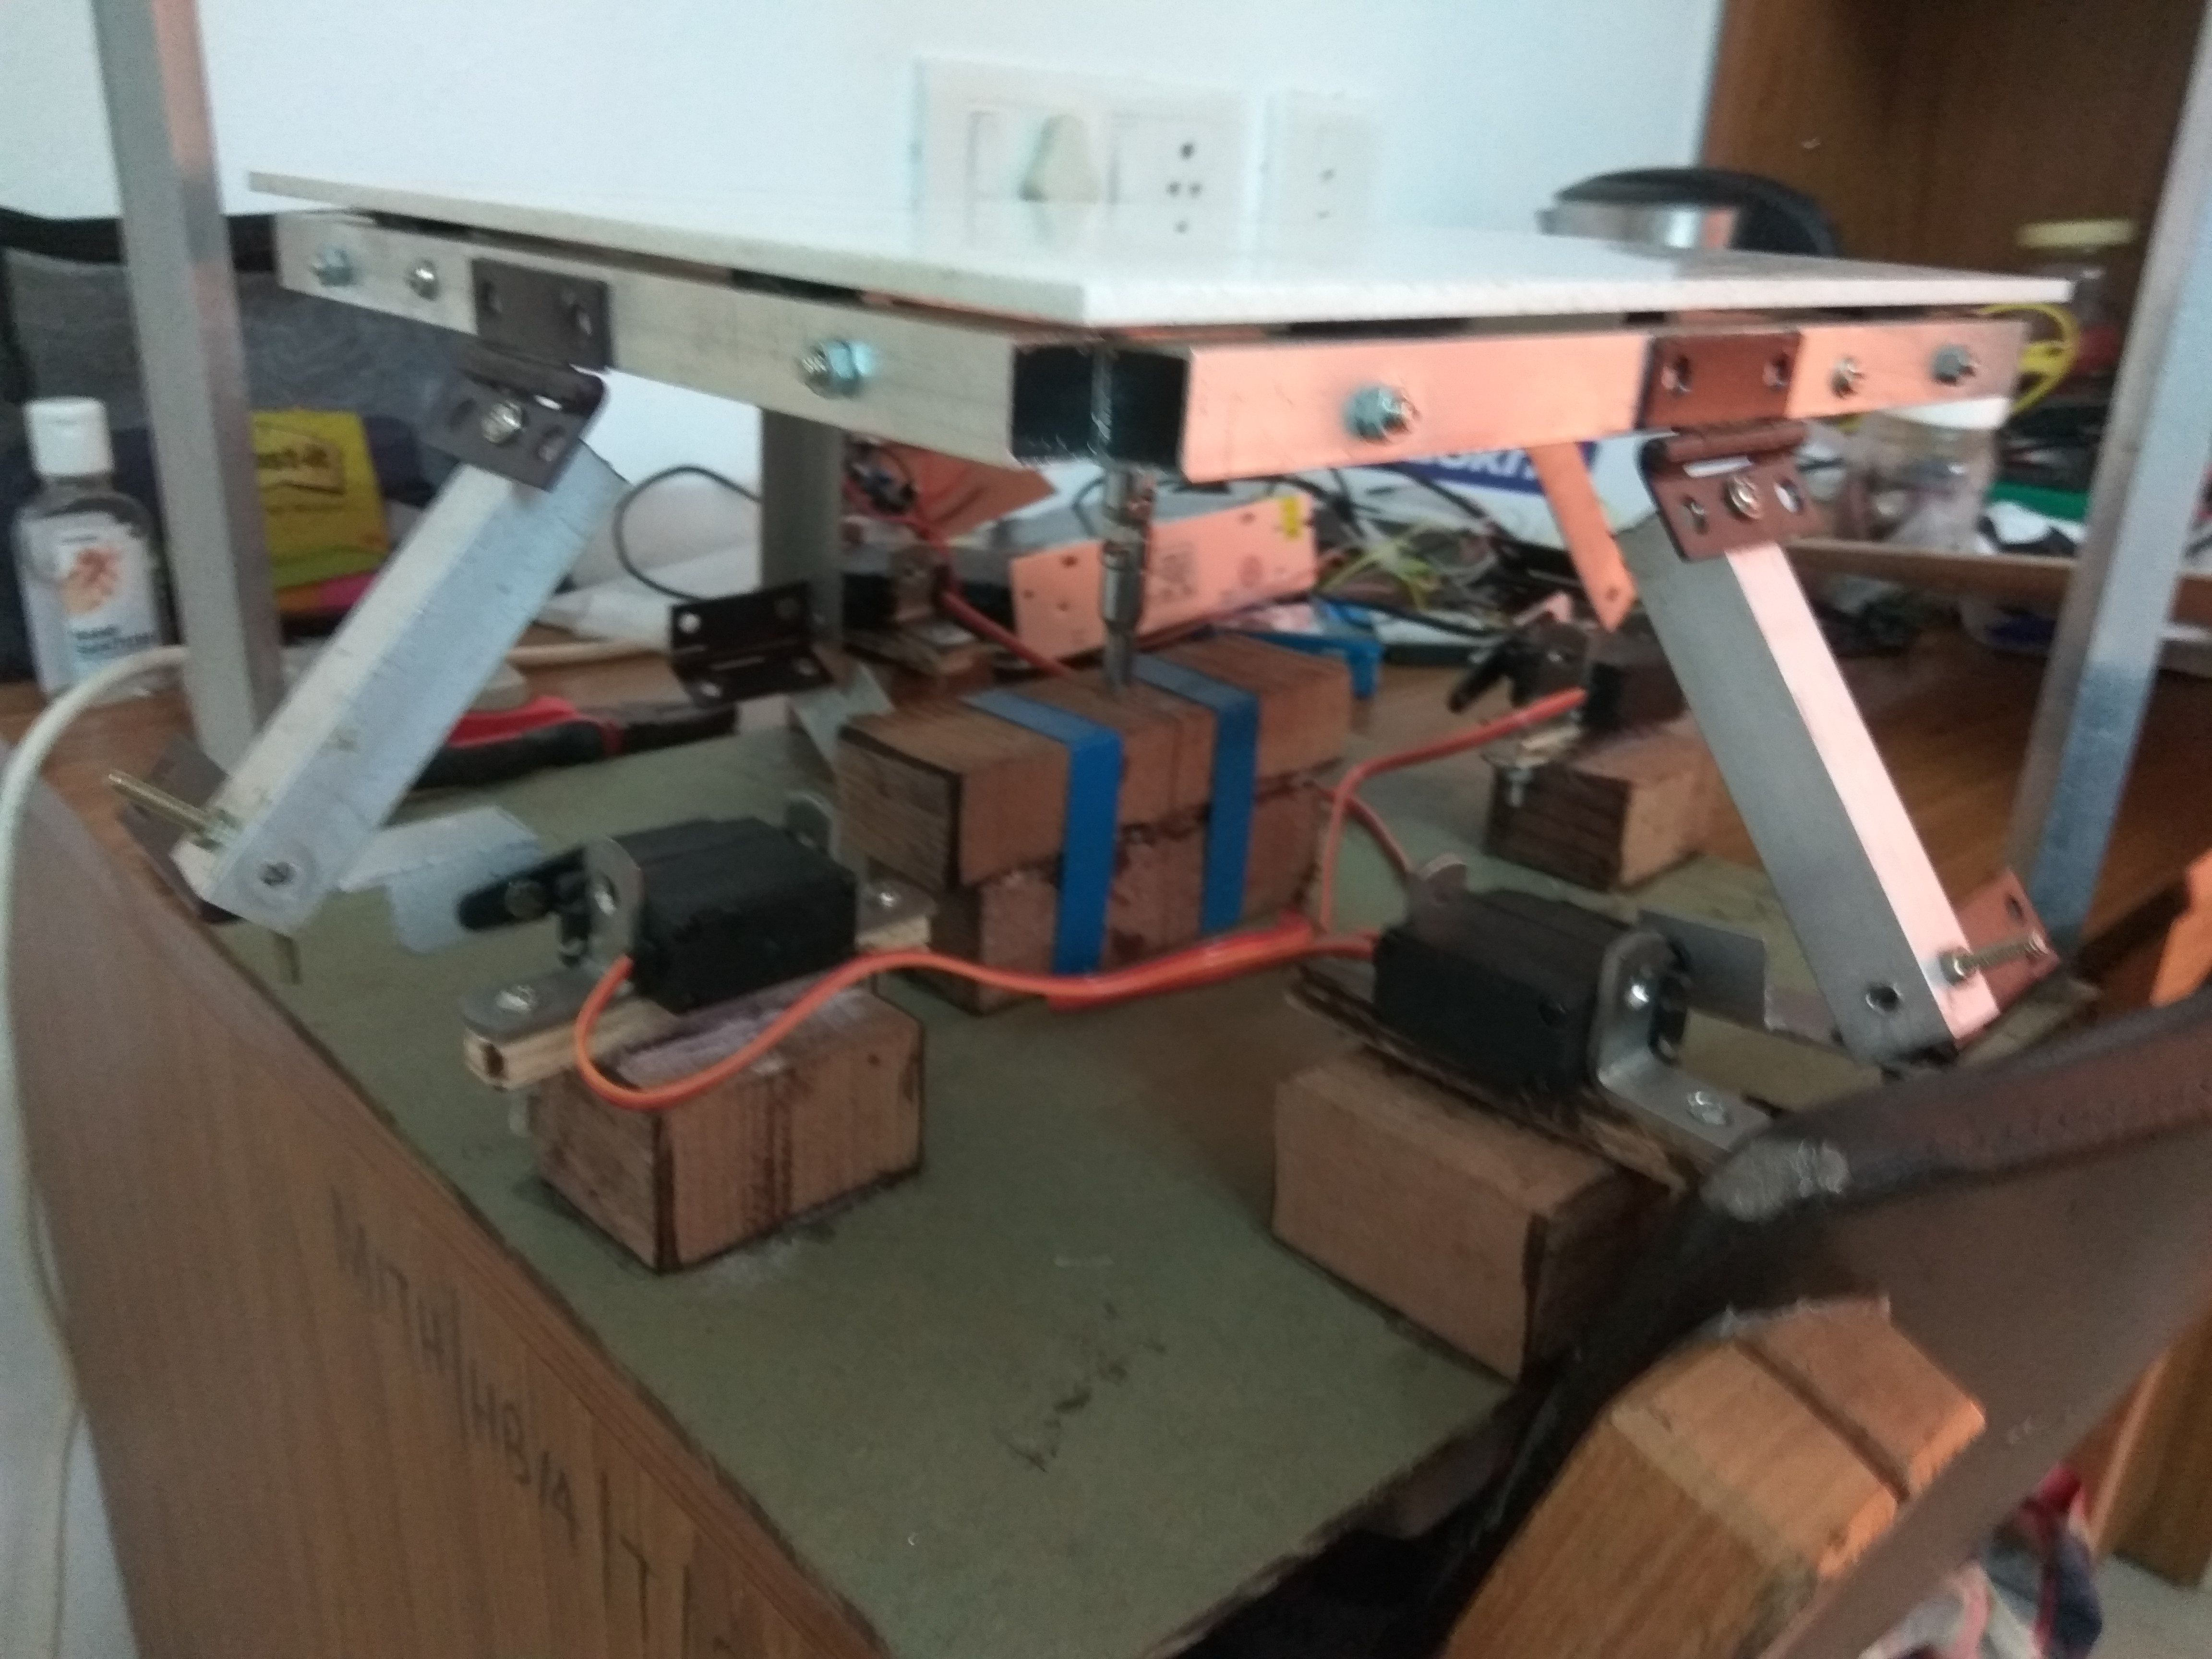

Figure 4.7: Second iteration: Linkages

**CHAPTER 5**

**CONCLUSION AND FUTURE SCOPE OF WORK**

**5.1 Work Conclusion**

The Author aims to develop a linkage based Ball-on-Plate System with a supporting Graphical User Interface to aid as an educational and visualization tool and as a testbench for various control systems.

With the fabrication of the mechatronic system and the development of the mathematical model and the Computer Vision Algorithm, work on system development and the sensing is complete. These form the supporting basis for the project and serve as the building blocks using which the controller will be built.

The proposed system is a linearized simplification of a complex nonlinear and unstable system. While it provides advantages in the form of simplified processing and the capability of testing classical control algorithms, the accuracy of the model is affected due to various assumption made during the linearization process. The choice of CV as the sensing modality provides acceptable ball position detection at an affordable price compared to touch screen sensing.

**5.2 Future Work**

With the basis built and tested, the focus of the project will be shifted to controller development. Various control schemes will be implemented and an overwrapping GUI will be developed to enable the system to be used as a desktop evaluation and comparison tool.

**REFERENCES**

1. S. Awtar, C. Bernard, N. Boklund, A. Master, D. Ueda, and K. Craig, “Mechatronic design of a ball-on-plate balancing system," Mechatronics, vol. 12, pp. 217-228, 2002.
2. A. Knuplez, A. Chowdhury, and R. Svecko, “Modeling and control design for the ball and plate system," in IEEE International Conference on Industrial Technology, vol. 2, pp. 1064-1067, IEEE, 2003.
3. J. H. Park and Y. J. Lee, “Robust visual servoing for motion control of the ball on a plate," Mechatronics, vol. 13, pp. 723-738, 2003.
4. M. Moarref, M. Saadat, and G. Vossoughi, “Mechatronic design and position control of a novel ball and plate system," in Mediterranean Conference on Control and Automation, vol. 2, pp. 1071-1076, IEEE, 2008.
5. A. Jadlovska and S. Jajcisin, “Modelling and pid control design of nonlinear educational model ball plate," in 17th International Conference on Process Control, vol. 2, pp. 871-874, 2009.
6. M. Nokhbeh and D. Khashabi, “Modeling and control of ball-plate system", Master's thesis, Amirkabir University of Technology, 2011.
7. S. Kinoshita, T. Hirogaki, E. Aoyama, and W. Wu, “Robust visual servoing for motion control of the ball on a plate," in ASME International Mechanical Engineering Congress and Exposition, vol. 2, pp. 653-659, American Society of Mechanical Engineers, 2013.
8. C. C. Ker, C. E. Lin, and R. T. Wong, “Tracking and balance control of a ball and plate system," Journal of the Chinese Institute of Engineers, vol. 30, pp. 459-470, 2007.
9. P. Corke and G. Hager, “Vision-based robot control," Control Problems in Robotics and Automation, vol. 230, pp. 45-52, 1998.
10. “Rki-1211 digital servo datasheet." https://robokits.co.in/motors/high-torque-metal-gear-standard-digital-servo.
11. “Pigpio raspberry pi library." http://abyz.me.uk/rpi/pigpio/.

PROJECT DETAILS

|  |  |  |  |
| --- | --- | --- | --- |
| *Student Details* | | | |
| **Student Name** | **K Akanksh Pratheek Reddy** | | |
| Register Number | 140907050 | Section / Roll No | B / 06 |
| Email Address | akanksh.pratheek@gmail.com | Phone No (M) |  |
|  | | | |
| *Project Details* | | | |
| **Project Title** | **Development of GUI Based Controller for Ball-on-Plate System** | | |
| Project Duration | 4 Months | Date of reporting | 8th January |
| Expected date of completion of project | 25th April 2018 |  |  |
|  |  | | |
| *Organization Details* | | | |
| **Organization Name** | **Manipal Institute of Technology** | | |
| Full postal address with pin code | Manipal, 576104 | | |
| Website address | [www.manipal.edu](http://www.manipal.edu) | | |
|  |  | | |
| *External Guide Details* | | | |
| **Faculty Name** | **Mr. Mukund Kumar Menon** | | |
| Designation | Asst. Professor, Senior Scale | | |
| Full contact address with pin code | Department of I&C Engg., Manipal Institute of Technology, Manipal, - 576104 | | |
| Email address | mukund.menon@manipal.edu | Phone No (M) | +91 9481146651 |
|  |  | | |
| *Internal Guide Details* | | | |
| **Faculty Name** | **Dr. K Prabhakar Nayak** | | |
| Full contact address with pin code | Dept. of E&C Engg., Manipal Institute of Technology, Manipal – 576 104 (Karnataka State), INDIA | | |
| Email address | kp.nayak@manipal.edu | | |